Create A Database In Cloudant DB

✓ To create a database in Cloudant DB to store location data

Steps:

1. Log in to IBM Cloud account
2. Click “Create Resource +” button

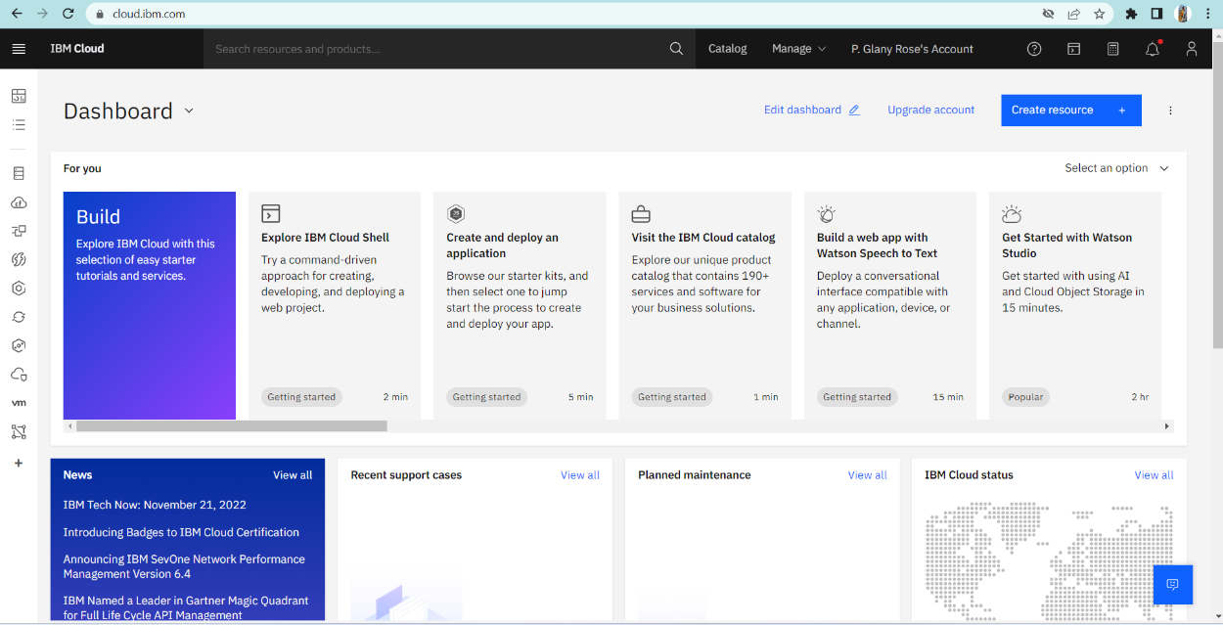

1. Search for “Cloudant”
2. Choose the “Lite Version” 5. Click on “Create”

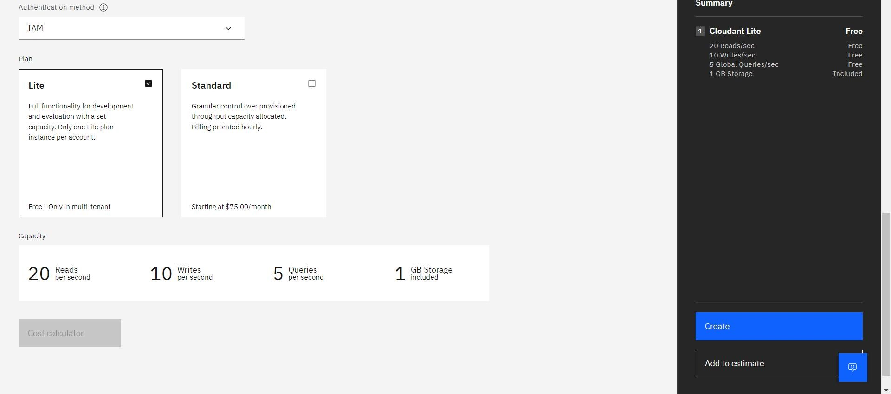

6.The Cloudant database resource created

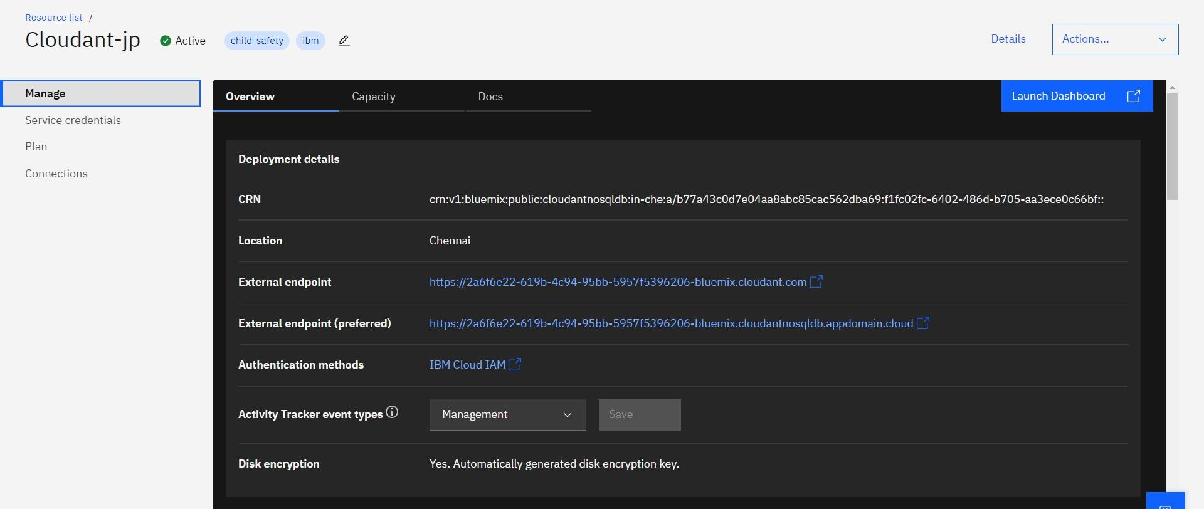

7.click on launch dashboard

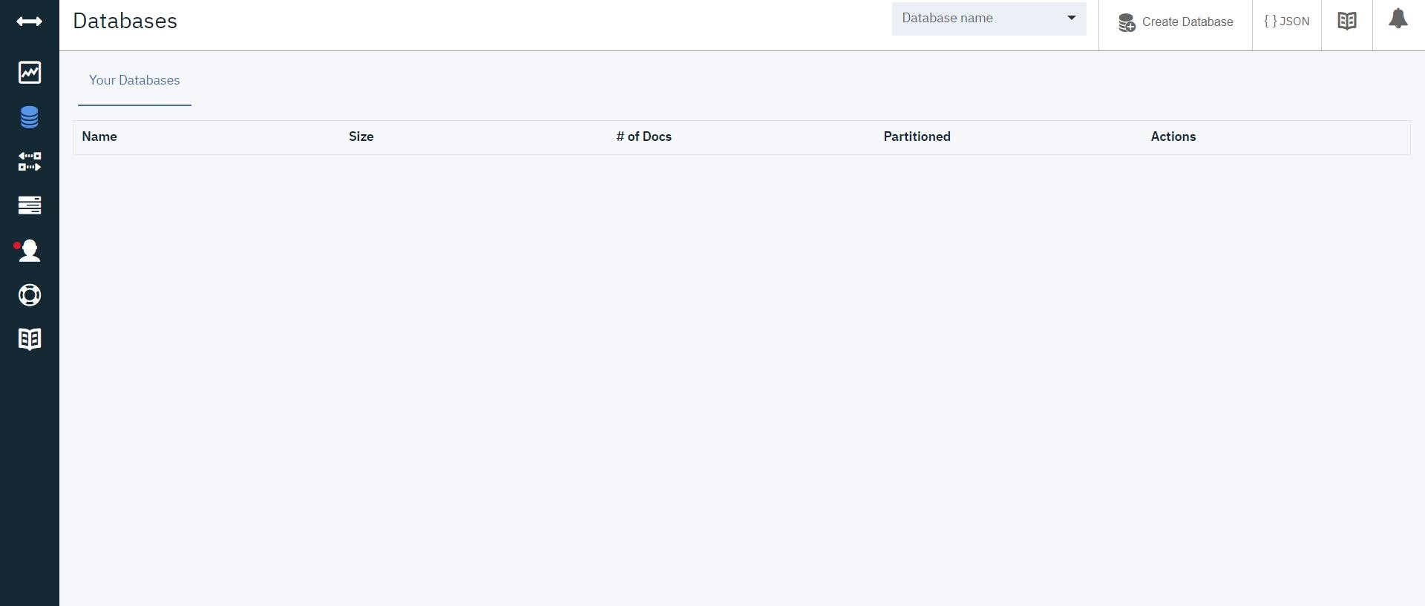

8.Click “Create Database”. Entered “Glany rose” as the database name and the “non-partitioned” option 9. The database “Glany rose” has been created.

Conclusion:

A database to store the location data on Cloudant DataBase has been created successfully.